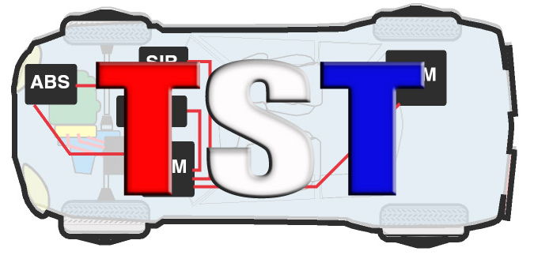

Technicians Service Training

"The Twentieth Annual TST Tech Training Big Event"

Event Date: Saturday, March 18th, 2023 - Event starts at 8 AM to 6:30 PM
After Party (in Vendor Room) 6:30 – 9:00pm
(Attendee check-in starts at 6:30am)

Location: Westchester Marriott 670 White Plains Road, Tarrytown, NY 10591
#800 882-1042

COMPANY NAME: ____________________________________________________________________

ADDRESS: ____________________________________________________________________________

TEL. #:__________________________ EMAIL: _____________________________________________

$10,000.: Platinum Sponsorship - 6 Representatives,
$150. ea. additional rep. (Max 8)

Representative’s names attending event: (Please Print) clearly for name badge):

- _________________________________________
- _________________________________________
- _________________________________________
- _________________________________________
- _________________________________________
- _________________________________________
ADDITIONAL REPRESENTATIVES:

- _________________________________________
- _________________________________________

PLEASE EMAIL FORM TO doreen@tstseminars.org - Questions call 845 628-1062
This event will be presented snow, rain or shine, NO REFUNDS!

