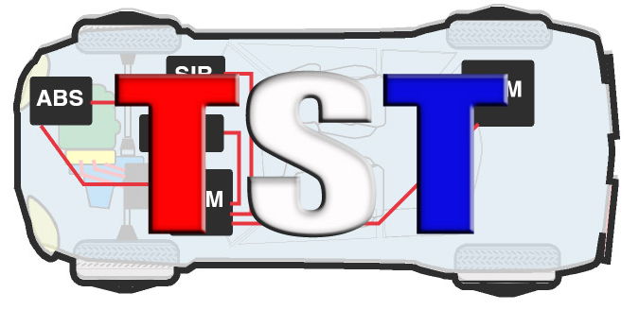

Technicians Service Training

"The Twentieth Annual TST Tech Training Big Event"

Event Date: Saturday, March 18th, 2023 - Event starts at 8 AM to 6:30 PM
After Party (in Vendor Room) 6:30 – 9:00pm
(Attendee check-in starts at 6:30am)

Location: Westchester Marriott 670 White Plains Road, Tarrytown, NY 10591
#800 882-1042

COMPANY NAME: ____________________________________________________________________

ADDRESS: ____________________________________________________________________________

TEL. #:__________________________ EMAIL: _____________________________________________

$1,000.: 1-6 x 6 Ft. Table 2 Representatives
$150. Additional rep (Max 3)

Representative’s names attending event: (Please Print for name Badge):

- _________________________________________
- _________________________________________

ADDITIONAL REPRESENTATIVE:

- _________________________________________

Please email form to doreen@tstseminars.org - Any questions call 845 628-1062

This event will be presented snow, rain or shine, NO REFUNDS!

